**Project Development Phase Model Performance Test**

|  |  |
| --- | --- |
| Date | 18 November 2022 |
| Team ID | PNT2022TMID23445 |
| Project Name | Project – Web Phishing Detection |
| Maximum Marks | 10 Marks |

# Model Performance Testing:

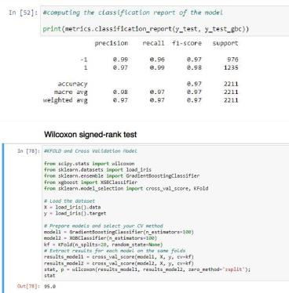Project team shall fill the following information in model performance testing template.

|  |  |  |  |
| --- | --- | --- | --- |
| **S.No.** | **Parameter** | **Values** | **Screenshot** |
| 1. | Metrics | **Classification Model:**  **Gradient Boosting Classification**  Accuray Score- 97.4% |  |
| 2. | Tune the Model | Hyperparameter Tuning - 97% Validation Method – KFOLD & Cross Validation Method |  |

# METRICS: CLASSIFICATION REPORT:

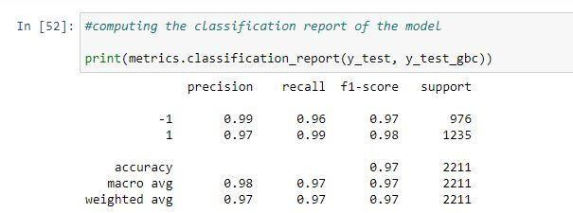

**PERFORMANCE :**

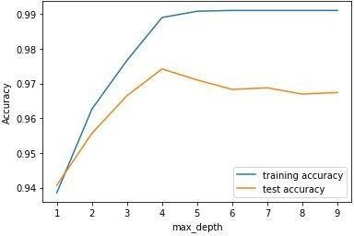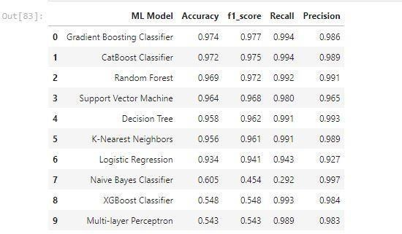

1. **TUNE THE MODEL – HYPERPARAMETER TUNING**

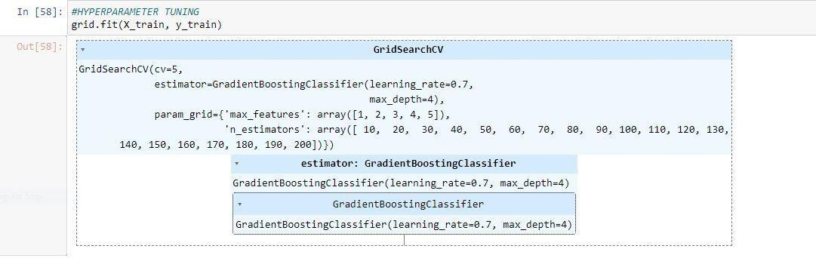

**VALIDATION METHODS: KFOLD & Cross Folding**

